Totem Architecture and Notes

The Nimba Totem Light is a fully off-grid solar-powered community beacon that provides lighting, USB charging, flood/heavy-rain alerts, and local data logging for community resilience. It combines renewable power hardware, an ESP32-based control layer, alert communication via radio and/or meteorological API, and local storage for event history, with optional 4G synchronization when available.
The system is designed to receive environmental alerts, process them locally, drive visual and charging outputs, and store operational data in a tamper-resistant enclosure. Its architecture emphasizes low power consumption, simple community-readable signalling, and modularity so each subsystem can be maintained independently.
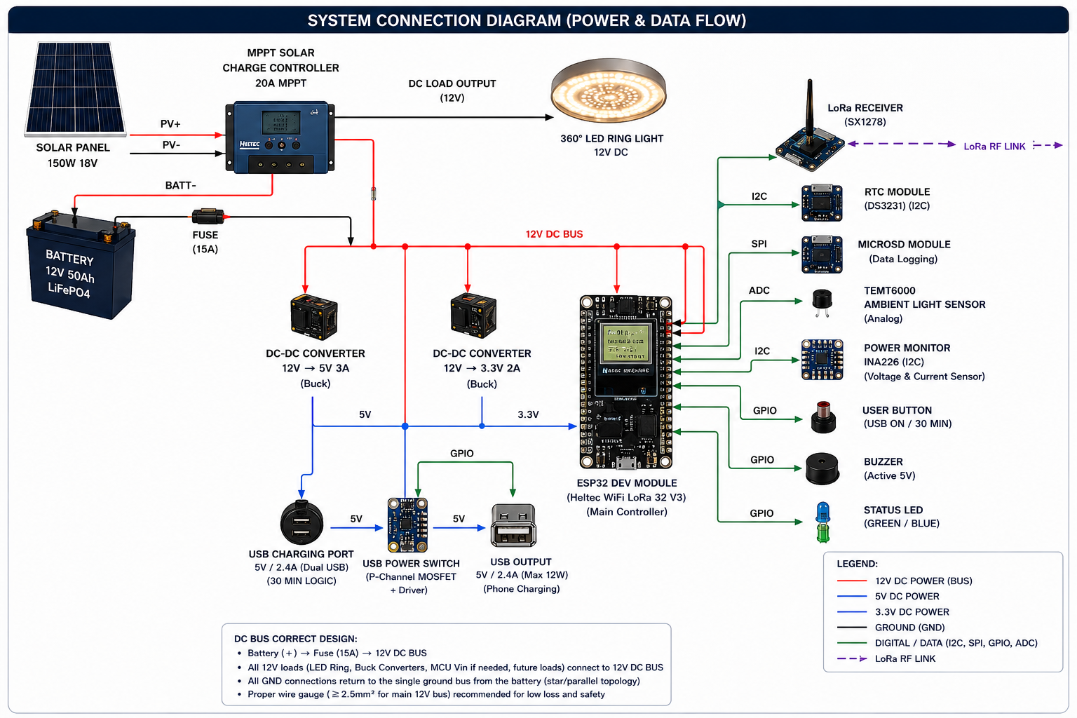

Component Specifications, Roles, and Interfaces
Component Name | Key Specification | Role (What it does) | Interface (How it talks to the Brain)
Solar Panel | 150W, 18V | Captures sunlight and generates raw electricity. | Wired directly to the Charge Controller.
MPPT Solar Charge Controller | 20A MPPT | Safely converts raw solar power into the perfect voltage to charge the battery. | Heavy-duty power wires.
Battery | 12V 50Ah ($LiFePO_4$) | Stores electricity safely. Lithium Iron Phosphate ($LiFePO_4$) is incredibly safe and lasts for years. | Connected to the main system through a 15A Fuse for safety.
ESP32 Dev Module | Heltec WiFi LoRa 32 V3 | The Brain. Controls everything, handles timing, and sends data over long distances. | Central Hub (uses 3.3V power).
360° LED Ring Light | 12V DC | Provides powerful, bright illumination around the totem. | Managed by the brain via a switch.
DC-DC Converter (5V) | 12V to 5V (3A Buck) | Stepped-down power "transformer" to create a safe 5V line for the USB chargers. | Power conversion line (Blue).
DC-DC Converter (3.3V) | 12V to 3.3V (2A Buck) | Stepped-down power "transformer" to create a clean 3.3V line to power the Brain. | Power conversion line (Light Blue).
USB Ports & Power Switch | 5V / 2.4A (Max 12W) | Safely charges user phones. Features a smart automatic timer. | Control line (GPIO) from the Brain.
LoRa Receiver | SX1278 (Built-in) | A long-range, low-power radio that can send data miles away without internet. | LoRa RF Link (Wireless).
RTC Module | DS3231 | A high-accuracy digital clock with a tiny backup battery so the totem always knows the real time. | I2C (A 2-wire digital communication highway).
MicroSD Module | Data Logging | A memory card slot to save backup records locally. | SPI (A high-speed digital data highway).
Ambient Light Sensor | TEMT6000 | The "eyes" of the totem. It measures how bright or dark it is outside. | ADC (Analog signal converted to digital numbers).
Power Monitor | INA226 | The health monitor. It tracks exactly how much electricity is flowing. | I2C digital highway.
User Button | Momentary Push Button | A physical button for people to press to activate the USB charging for 30 minutes. | GPIO (Simple On/Off signal wire).
Buzzer | Active 5V | An alarm that makes a loud noise during emergencies. | GPIO (Simple On/Off signal wire).
Status LED | Green / Blue Light | A small indicator light to show if the system is working perfectly or has an error. | GPIO (Simple On/Off signal wire).

Estimated Power Consumption Table
Component | Operating Voltage | Current Draw (Est.) | Power (Watts) | Active Time / Behavior
ESP32 Brain | 3.3V | ~100 mA | 0.33 W | Always ON (24/7 monitoring)
LoRa Radio | 3.3V | ~120 mA (when transmitting) | 0.40 W | Intermittent (Flashes data every few seconds)
LED Ring Light | 12V | ~1.0 A to 1.5 A | 12.0 W – 18.0 W | Nighttime Only (Or when light sensor is covered)
MicroSD + Sensors | 3.3V / 5V | ~50 mA combined | 0.20 W | Always ON (Low power draw)
USB Charging Port | 5V | Up to 2.4 A | 12.0 W (Max per device) | On-Demand (Only runs for 30 mins when button is pushed)
Buzzer & Indicator | 5V | ~30 mA | 0.15 W | Emergency Only (During simulated flood alert)

Total System Power Profiles
- Idle Profile (Daytime, No USB): ≈1.5W
- Night Profile (Dimmed, 1AM–Dawn, No USB): ≈12W
- Peak Profile (7PM–1AM, Max USB Charging + LoRa Event): ≈55W−60W

1-Power Architecture: Voltage Splitting & Regulation
How is the 12V split into 5V and 3.3V?
Instead, the architecture utilizes two DC-DC Buck Converters (Step-Down Switching Regulators). They act as high-efficiency "choppers" that convert high-voltage/low-current into low-voltage/high-current with minimal heat dissipation (≈90−95% efficiency).
What device is the "Bus Controller"?
The Heltec WiFi LoRa 32 V3 (ESP32) is the primary microcontroller. While it does not physically switch the raw power lines directly, it acts as the Logical Bus Controller. It manages power distribution by driving the gates of the MOSFET switches via its GPIO pins (e.g., turning on/off the USB subsystem and sending PWM to the LED driver).
- Power Monitoring Sensor: The INA226 (or INA220/216) is used to measure both current and voltage.
- Voltage Measurement: Connected in parallel across the 12V DC Bus.
- Current Measurement: Connected in series across a high-precision, ultra-low resistance shunt resistor. It communicates this data back to the Heltec MCU via the I2C communication protocol (SDA/SCL lines).
2-Light Control, Dimming, and Automation Logic
How is the light controlled via the LED Driver and Timeframe Logic?
The 360° LED ring runs on 12V DC and demands high current (30W−60W→2.5A−5A), which would instantly destroy a microcontroller pin.
To bridge this, a Logic-Level N-Channel MOSFET (the LED Driver) is introduced. The Heltec MCU sends a low-power PWM (Pulse Width Modulation) signal from its GPIO pin to the Gate (G) of the MOSFET. By varying the duty cycle of this PWM signal (e.g., 100% duty cycle for full brightness, 30% duty cycle for dimmed mode), the MOSFET rapidly switches the 12V ground line on and off, controlling the light intensity without wasting energy.
Introducing a Light Sensor for Exhibition/Demonstration
To easily demonstrate the light turning on when dark, you should add a TEMT6000 Ambient Light Sensor to the Heltec MCU.
Connection: Connect it to an Analog Input Pin (e.g., ADC1_CH0 on the ESP32).
Exhibition Trick: You can cover the sensor with your hand or a cup to simulate "Night" instantly, forcing the Totem to automatically switch from Idle to Bright/Dimmed modes right on the showroom floor.
Unified Control Logic Framework
The MCU combines the DS3231 RTC (Real-Time Clock) time data with the Light Sensor data to make decisions:
IF (Light_Sensor < Threshold_Dark) OR (Time >= 19:00 AND Time < 01:00) {
Set PWM Duty Cycle to 100% (Full Brightness - 40W)
} ELSE IF (Time >= 01:00 AND Time < Dawn) {
Set PWM Duty Cycle to 30% (Dimmed Saving Mode - 12W)
} ELSE {
Set PWM Duty Cycle to 0% (Light Off - System Charging)
}
3-USB Charging Logic & 30-Minute Timer
The USB power rail is isolated using a High-Side P-Channel MOSFET switch controlled by an ESP32 GPIO pin.
How the Timer WorkS?
- Trigger: The user presses the momentary Push Button. This pulls an internal ESP32 pull-up GPIO pin to LOW (Interrupt triggered).
- Action: The ESP32 wakes up the USB sub-system by pulling the USB Power Switch GPIO line LOW (which opens the P-channel MOSFET and lets 5V flow to the USB port).
- Timer Initialization: The ESP32 records the current time using millis() or the RTC
Start
- Count Down: The ESP32 continuously checks if Current Time−T
start
≥30 minutes (1,800,000 ms).
- Cut-off: Once 30 minutes lapse, the ESP32 drives the GPIO line HIGH, closing the MOSFET channel, shutting off the 5V USB output automatically.
4-System Integration, Wiring, and Cables
Cable and Wire Specifications
Connection Path | Current Load | Recommended Cable Type
Solar Panel $\rightarrow$ MPPT Input | Up to 8.3A | 10 AWG or 12 AWG Solar Cable (PV Rated, Weatherproof)
Battery $\rightarrow$ MPPT Terminals | Up to 15A (Peak) | 10 AWG Copper Stranded Wire
MPPT Load Output $\rightarrow$ 12V DC Bus | Up to 10A | 12 AWG Copper Stranded Wire
12V Bus $\rightarrow$ LED Ring Light / Driver | Up to 5A | 14 AWG or 16 AWG Stranded Wire
12V Bus $\rightarrow$ DC Buck Converters | < 2A | 18 AWG Wire
Buck Converter $\rightarrow$ USB Ports / MCU | Up to 3A | 20 AWG or 22 AWG Hookup Wire
Sensors, Buttons, I2C, SPI Bus | < 50mA | 24 AWG or 26 AWG Dupont / Jumper Wires

The "Box That Splits in Two"
The physical box housed in the base of the totem is an IP66 Detachable Electronics Enclosure. It acts as a dual-zone housing:
Zone 1 (High Power & Storage): Contains the heavy 12V 50Ah LiFePO4 Battery and the MPPT Solar Charge Controller.
Zone 2 (Control & Logic): Houses the Heltec MCU, the Buck Converters, Power Monitoring sensors, and peripheral driver circuits on a centralized PCB/Perfboard.
5-Solar Controller & Outputs
What Solar Controller do I need?
A 12V/20A MPPT (Maximum Power Point Tracking) Solar Charge Controller.An MPPT controller will optimize the 150W solar panel’s output voltage () down to the battery charging voltage (), increasing charging efficiency by up to 30%.
What are the 3 connection points on the controller?
An MPPT controller has 3 distinct pairs of screw terminals (6 slots total):
- PV Input (+ / -): Two wires coming directly from the Solar Panel.
- Battery Terminals (+ / -): Two thick wires running directly to the LiFePO4 Battery terminals to manage safe charging and float cycles.
- DC Load Output (+ / -): Two wires running out to power your 12V DC Bus. This output is perfect because it features integrated low voltage disconnect (LVD) to prevent your totem from over-discharging and killing the battery.
6-Communication Architecture & Flood Alert Simulation
System Protocols (How they talk):
- Concentrator / Main Controller to Sensors: Uses I2C Protocol (2 wires: SDA, SCL) for the INA226 Power Monitor and DS3231 RTC. Uses SPI Protocol (4 wires: MOSI, MISO, SCK, CS) for the MicroSD Card Logger.
- Inter-Device Communication (Totem to Office): Uses LoRa Point-to-Point (P2P) Frequency modulated RF Link ( or ).
How to set up the Exhibition Demo (Flood Warning Simulation)
For your proof of concept, you will have two distinct, un-wired Heltec units operating completely wirelessly:

[EXHIBITION MET OFFICE DESK] [EXHIBITION FLOOR - SMART TOTEM]
Heltec WiFi LoRa 32 V3 Heltec WiFi LoRa 32 V3 (In Base)
+ Push Button (Trigger) + LoRa Antenna
+ LoRa Antenna │
│ ▼ Receives packet
└───► Broadcasts LoRa P2P Packet ──────────────┘ Enters "Flood Alert State"
{"type":"FLOOD_ALERT", "level":1} * 360° Ring Flashes Blue
* Status RGB Flashes Blue
* Active Buzzer sounds
Transmitter Unit (Met Office Desk Demo): A standalone Heltec V3 board powered via a power bank or USB cable sitting on a table. It has a single Push Button attached to it. When pressed, it broadcasts a LoRa string payload: {"type": "FLOOD_ALERT", "level": 1}.
Receiver Unit (Inside the Totem Base): The main Heltec V3 controller listens on the exact same LoRa frequency/spreading factor configuration. Upon receiving this specific string, it immediately overwrites the standard time/light cycle rules, overrides the LED driver to change colors or flash, triggers the Buzzer Driver, and blinks the status light indicator.
7-Status LED Threshold Logic (Green / Amber / Red)
To prevent system failures, the Heltec MCU tracks the battery's Capacity/Voltage through the INA226 sensor and updates the status LED based on calibrated boundaries.
Because LiFePO4 batteries have an incredibly flat discharge curve, triggering thresholds solely on voltage can be tricky. Here are the recommended industry engineering thresholds for a 12V (4-cell) LiFePO4 Battery pack:

Battery Capacity % | Voltage Range Equivalent | Status LED State | System Behavior Mode
$> 30\%$ | $> 13.0\text{V}$ | Solid Green |  | Normal Operation: All features (Lighting, LoRa, 30-min USB charging) are completely operational.
$20\% - 30\%$ | $12.8\text{V} - 13.0\text{V}$ | Slow Flashing Yellow |  | Low Power Mode: Totem light maximum brightness capped at 50%. USB charging intervals reduced to 15 minutes to preserve essential functions.
$< 20\%$ | $< 12.8\text{V}$ | Solid Red |  | Critical Battery Mode: System enters survival state. USB charging port is completely locked out. LED Ring remains unlit unless an active LoRa flood alert overrides it.
$< 10\%$ | $< 12.0\text{V}$ | Off |  | Deep Sleep Mode: The MCU cuts off all peripherals and enters deep sleep to protect the lithium cells from permanent undervoltage damage.

float batteryVoltage = readIna226Voltage();

if (batteryVoltage >= 13.0) {
setRGBColor(0, 255, 0); // Green
enableUSB = true;
} else if (batteryVoltage < 13.0 && batteryVoltage >= 12.8) {
setRGBColor(255, 255, 0); // Yellow/Amber
enableUSB = true;
} else if (batteryVoltage < 12.8 && batteryVoltage >= 12.0) {
setRGBColor(255, 0, 0); // Red
enableUSB = false; // Disable power hungry components
} else {
setRGBColor(0, 0, 0); // Turn Off/Deep Sleep
goToDeepSleep();
}

Estimated Power Consumption Table
Component | Operating Voltage | Current Draw (Est.) | Power (Watts) | Active Time / Behavior
ESP32 Brain | 3.3V | ~100 mA | 0.33 W | Always ON (24/7 monitoring)
LoRa Radio | 3.3V | ~120 mA (when transmitting) | 0.40 W | Intermittent (Flashes data every few seconds)
LED Ring Light | 12V | ~1.0 A to 1.5 A | 12.0 W – 18.0 W | Nighttime Only (Or when light sensor is covered)
MicroSD + Sensors | 3.3V / 5V | ~50 mA combined | 0.20 W | Always ON (Low power draw)
USB Charging Port | 5V | Up to 2.4 A | 12.0 W (Max per device) | On-Demand (Only runs for 30 mins when button is pushed)
Buzzer & Indicator | 5V | ~30 mA | 0.15 W | Emergency Only (During simulated flood alert)

